** STREAM:**

**Joy**

**Reflect on a moment of positive connection with someone recently**

Think about who you shared that moment with and what made it joyful.

What is one word that describes the feeling of that connection?

**1. Positive Impact of Joy**

PARTNER ACTIVITY: Reflection on connecting with moments of joy

**Reflect on a meaningful connection with a patient or colleague**

What were the joy moments of “mutual delight” you shared?

Why was it meaningful to you?

What allowed you to experience that connection at that time (e.g., setting, your frame of mind)?

GROUP DEBRIEF

**2. Continuing with Joy**

GROUP ACTIVITY: Making space for Joy

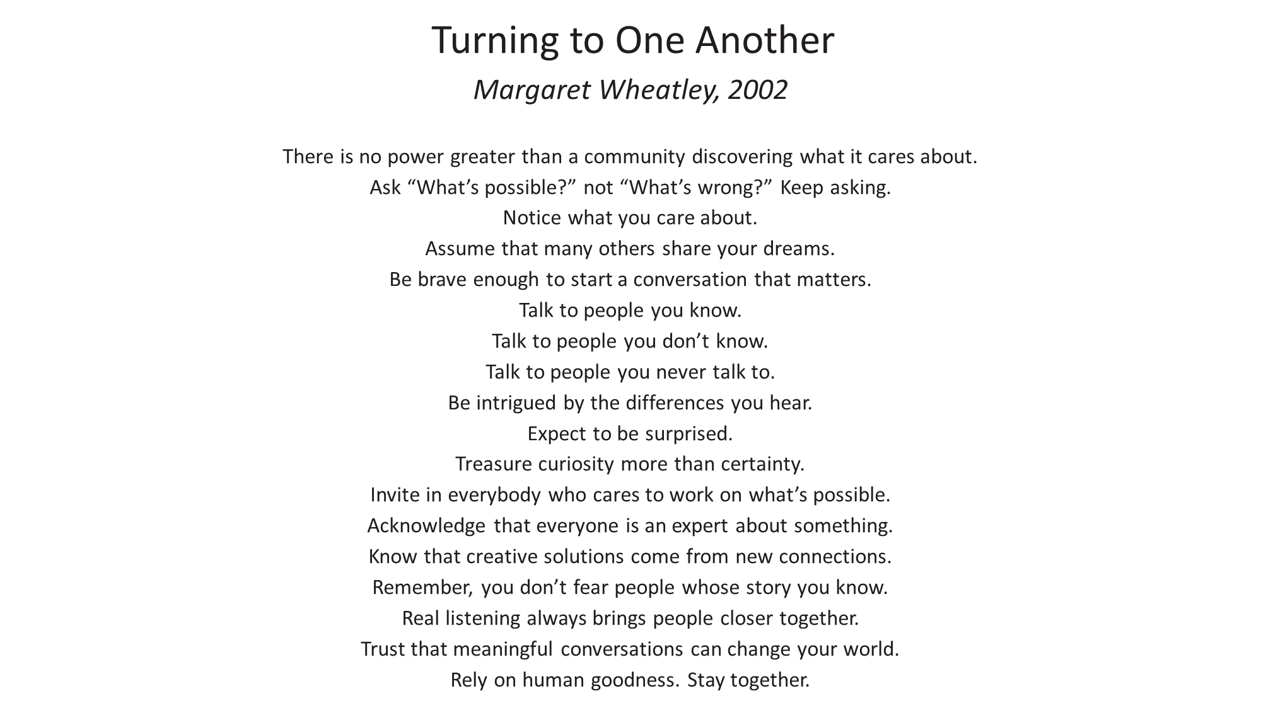

Resources for Support

1. [Physician Support Line](https://www.physiciansupportline.com/)

**1 (888) 409-0141**

<https://www.physiciansupportline.com/>

Psychiatrists helping US physician and medical student colleagues navigate the many intersections of our personal and professional lives.

Free, Confidential & Anonymous

No appointment necessary

Call for any issue, not just a crisis

They report to no one

Open Monday to Friday (except federal holidays)

8:00 AM - 12:00 AM ET

2. Warmlines - Mental Health America

If you are in need of support, but not in crisis, consider reaching out to a warmline

The website [**warmline.org**](http://warmline.org/) keeps an up-to-date list of local and nationwide warmlines across the United States

Sometimes you just need to talk to someone about your mental health. It’s great when you can reach out to a loved one—but that’s not always possible. Fortunately, warmlines are there to help!

A warmline is a phone number you call to have a conversation with someone who can provide support during hard times. Whether you’re in crisis or just need someone to talk to, a warmline can help. Warmlines are staffed by trained peers who have been through their own mental health struggles and know what it’s like to need help.