STREAM: Improvement Project Tracking Form

Purpose: You can utilize this tool at regular intervals (biweekly or monthly) as an ongoing assessment

of the different aspects of your project and to guide your progress.

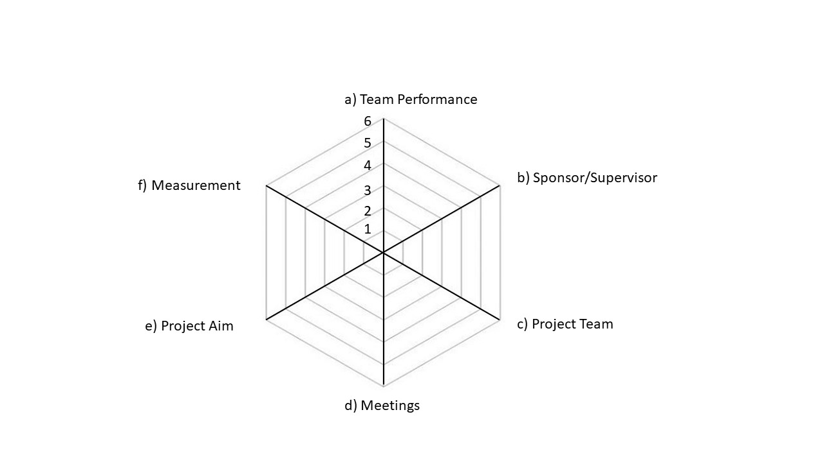

Descriptors:

a) Team Performance: Team enthusiasm remains high and team productivity is on target with project plan

b) Sponsor/Supervisor: Update at agreed upon intervals (defined in week)s

c) Project Team: Project team is in place and continues to be representative of the whole team

d) Meeting: Project team meets at agreed upon intervals

e) Project Aims: Agreed area of focus for the project; ensure project activities continue to support the aim

f) Measurement: You have established a desired outcome and have access to data needed to drive project

g) Team Performance: Team enthusiasm remains high and team productivity is on target with project plan

Measurements:

0) Never/Not in place

1) less than or equal to 10% of the time/in place

2) approximately equal to 30% of the time/in place

3) approximately equal to 50% of the time/in place

4) approximately equal to 70% of the time/in place

5) approximately equal to 90% of the time/in place

6) Every time/in place